GEOTECHNICAL ENGINEERING LABORATORY
CRTC Ref. No. | CRTC/CEE/G20220591 |  |  |  | Date of Issue |  | 12/04/2022
Client Information | Salim Uddin & Kabir Khan, Soil Farm- Relation Soil Investigation, Sylhet, Bangladesh
Project Name | 09 Storied C/B (S-109), South Surma.
Sample | Undisturbed Soil | Sample ID |  | Sealing Type |  | Sealed

UNCONFINED COMPRESSIVE STRENGTH TEST OF COHESIVE SOIL (ASTM D 2166)
Sample No. | Bore Hole No. | Depth (m) | Unconfined Compressive Strength (kN/m²) | Strain at Failure (%)
01 | 03 | 3.05  (10 ft) | 54.9 | 6.41

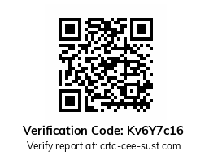

Test Assisted By: |  | Test Performed By: |  | Countersigned By:
A.H.M Humayun kabir  Senior Technical Officer  Dept. of CEE, SUST, Sylhet-3114 |  | Dr. Shriful Islam  Associate Professor  Dept. of CEE, SUST, Sylhet-3114 |  | Prof. Dr. H.M.A. Mahzuz  Coordinator, CRTC  Dept. of CEE, SUST, Sylhet-3114

